Annual Review bioRe® Foundation 2019/20

For a balance between humans and nature
By growing organic cotton and through related development projects, we stand up for human rights and fight against child labour and poverty in farming communities.

biore-stiftung.ch. I facebook.com/bioReStiftung I bioRe Foundation - YouTube

Aims of the bioRe® Foundation:
- Promoting organic cultivation of cotton in India and Tanzania, through research, education and capacity development of farmers.
- Building an infrastructure in the following areas: Education, health and agriculture as a sustainable support of farmer families in need.
- Organization structure and capital formation for the local implementation of the projects and direct collaboration with the farmers. The effective participation of organic farmers is the basis for the project work of bioRe® Foundation.
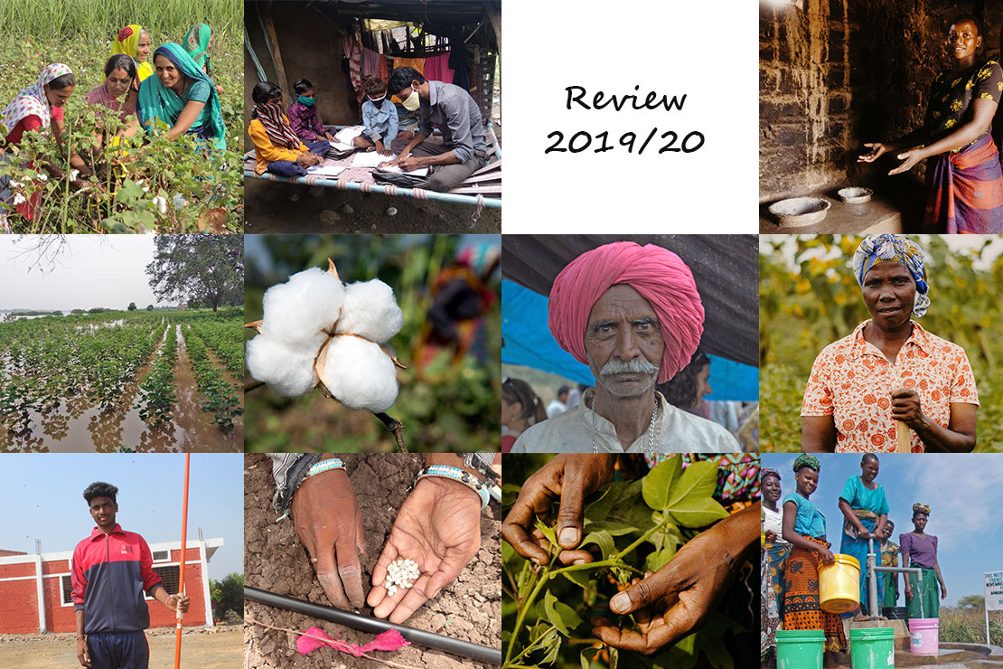
The right to education
is a human right according to Article 26 of the Universal Declaration of Human Rights and it demands: „The creation of institutional and material requirements for a complete realization of the right to education, as e.g. the availability of a respective infrastructure.“
Many children in rural areas in India do not have access to education. The danger that children from disadvantaged communities with no access to education or access to school end up doing child labour is big. At the same time, education is the key to better future prospects and an important foundation to overcome poverty by one’s own power. Through our village schools, we support children from kindergarten to the 5th grade in living their right to education.
The village schools are so called animation schools, which also raise the parents’ awareness of the meaning of school education for the development of children. Since 2006, 18 animation schools were founded in India. Currently, 1,268 children have access to a sound school education with a recognized school certificate through these schools.
Access to education enables individual freedom, empowerment and development.

Becoming a professional through education
“Everyone has the right to education... Primary school is mandatory. Technical and vocational education and training must be made generally accessible”
We pay special attention to the secondary school for the children of the animation schools in India. The transition from primary school to secondary school is especially important, as particularly girls often quit school before entering secondary school.
As a connecting solution for these children and with the generous support of Coop Fonds für Nachhaltigkeit, the bioRe school campus was set up in 2014 and extended in 2019. Thereby, the youth gets the possibility to do a further training at high school or to do a technical training. The vocational training courses offer the possibility to learn a locally relevant profession. Thereby, the youths from farmer communities obtain a certified degree for a successful start into professional life.
Currently, 635 children attend the school campus, of which 119 children come from the animation schools.

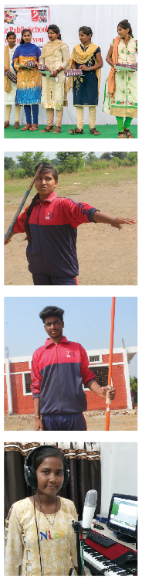
Achievements
The graduation celebration for the first generation of students of the bioRe animation school, which also graduated from secondary school took place on the “Open House Day” 2018.
Dipali Minawa is a student of the 10th grade. After graduating from the primary school at the animation school in the village Ahilyapura, she successfully changed to the secondary school. Dipali is an athlete and has achieved remarkable success in javelin throw in her region.
Rohit Ajnare equally entered the secondary school of the bioRe school campus after having graduated from primary school at the animation school in Ahilyapura. During the past year, he won three gold medals in the same athletic discipline as Dipali. Rohit had the chance to prove his excellent skills on a regional and national level.
Sandhya Dawar is a name you should remember. After having finished the primary school in Sadarban animation school, she made it to the secondary school and thanks to her talented voice, she now records songs in the music studio Khargone, which were published on YouTube.

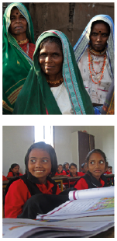
Impact
“I want to make education possible for my children for as long as they are interested in school”, says a mother, whose children visit the animation school in the village Jamniya. She herself only visited the first five years of primary school, because she had to support her parents working on the fields.
The big contribution of the school project in the village communities with no access to education is that an organized school day takes place and that the schools are regularly visited at all. The main purpose does not lie in the construction of the school building, but the transmission of knowledge and the offer of meaningful lessons. That is how many animation schools start, with little less than a simple shelter, slates and a few sitting mats. Often, the lessons first take place in the house of a farmer family, until a farmer provides land for the construction of a school building.
The farmers from the villages with an animation school experience that the state of the village has improved since it got access to education.

„...from the beginning on, Patrick Hohmann* focused on continuity also and specially when difficulties arise, and things don’t work the way they should. Loyalty and the constant readiness to listen, to stay in contact and to solve difficulties together are crucial for Hohmann...“ **
*Patrick Hohmann, founder, and honorary president of the bioRe® Foundation
**from the book „Patrick Hohmann - der Bio-Baumwollpionier“
The school project of the bioRe® Foundation is a project which must preserve its continuity.
During the national lockdown in India, caused by the pandemic, all schools were closed for over 2 months. Contrary to the “homeschooling” solutions in Switzerland and other European countries, the children in the remote areas of India do not have any alternatives to the regular school routine based on classroom teaching. There is no electricity in the villages in general and in the schools.

Your CHF 100 for the right to education:
Hereby, you cover the annual school expenses for one child.

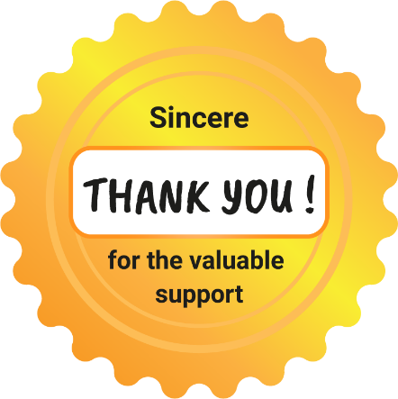

More about the social projects of the bioRe® Foundation and about donation options at: www.biore-stiftung.ch

Education is the future
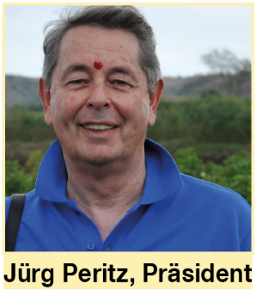
The right to education is for me personally one of the most important human rights. Without education, children are exposed to exploitation and abuse. Education is the future. Education fights poverty. School lays - and maybe this is as important as the content of the lessons - the foundation for a happy childhood with friendships and a daily routine.
Until today, there are about 120 million children in the world that do not visit school. How can they develop their personality and potential? Where should they get to know their rights - the human rights?
Freedom without discrimination, the right to work, freedom of expression, all these fundamentally important rights can only be transmitted through the access to schools.
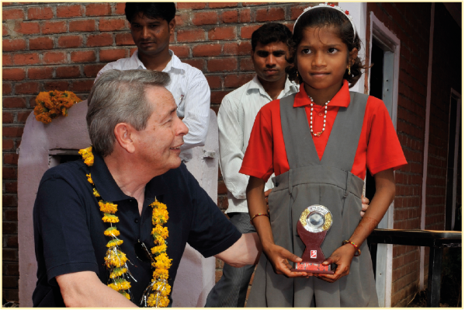
My most beautiful memories of the journeys to India are the visits to the children in the bioRe® schools. The shining eyes of the children, the happiness and the discipline, the simplicity and the commitment of the teachers have always moved me and inspired me to give the subject of education a high priority in our Foundation.
I hope to be able to continue to count on your support and thank you very much for your personal interest in the bioRe® Foundation and our projects in India and Tanzania.

Jürg Peritz, president of the bioRe® Foundation

During the past business year
We received generous support of our numerous donors, so that through our holistic approach for the sustainable development, we could expand the project work. Specially in the areas of promotion of organic agriculture, in the creation of education projects and through water projects, it was possible to expand the activities and the infrastructure significantly. The project support in favor of the farmer families in India and Tanzania could be increased by 30 %.
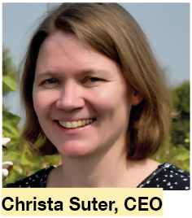
However, the last year showed us once more the vulnerability of the agricultural production, when an unusually long period of rainfall threatened to wash away harvests in India. In response to our emergency campaign, we experienced a lot of solidarity. The irregularities in agriculture always harbor big risks for the farmers. But also, the companies bioRe Ltd. India and bioRe Tanzania Ltd. got into difficulties and suffered losses. As a result, the investments in the bioRe Foundation had to be adjusted in their value.
The promotion of sustainable investments is of great importance and specially in times of global corona crisis the inequalities and poverty can be seen clearly. Therefore, now, it is more important than ever to support projects for farmer families specifically in order to provide possibilities and create room for a sustainable development. Thank you for supporting us in our endeavor for an organic GMO-free agriculture and in supporting us in realizing the human rights.

Key figures 2019-20
We are happy to send you the detailed annual statement upon request.
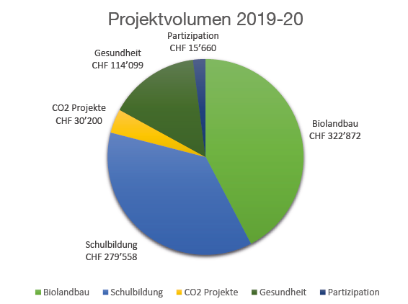
Project size 2019-20
Participation CHF 115,660
Health CHF 114,099
CO2 Projects CHF 30,200
School Education CHF 279,558
Organic Farming CHF 322,872

Distribution of project funds for organic agriculture 2019-20
Research CHF 72,657
Productivity CHF 177,745
Agricultural training CHF 72,471

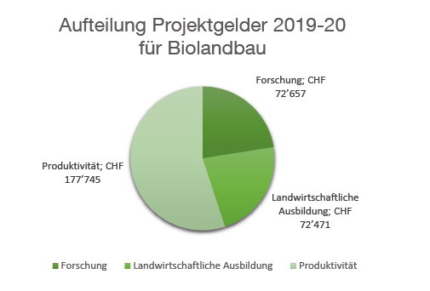

Project highlights 2019/20

bioRe® Association India

The bioRe® Foundation has been doing development work for 15 years, during which it has engaged with different social aspects of the community of organic farmers. During the past year, we specially invested in areas that were prioritized as basic needs of the communities:
- Operation of 18 animation schools and one secondary school with vocational training center
- Mobilization and training of 75 women groups on the subject water
- Operation of the health bus
- Construction of toilets for 50 families
- Repair of 75 biogas plants
- Research and education on the newest organic and biodynamic cultivation methods
With the support of Coop, the infrastructure of the school campus was expanded by a library and a laboratory and additionally, the vocational training center was expanded. The vocational training in the areas of organic agriculture, sewing, computer, electricity, and mechanics takes place on the BIORE® SCHOOL CAMPUS. With the new investments, the vocational training center reaches the national recognition (National Council of Vocational Training).
During corona and post corona times, school classes have to be adapted. In the animation schools, we try to support the children individually, as there is no possibility to connect digitally to them or their families. In the secondary school there is the solution, to complement school classes with solar powered technology, what will lead to a more reliable and sustainable school model. In the first pilot phase, an online live class is introduced for the students of the 8th, 9th, and 10th grade.
The project on water productivity, the WAPRO was started in 2019 with the support of DEZA and Helvetas. Its aim is to introduce different activities to transmit an efficient approach to water to the farmers.
Until the end of 2019, 75 women groups with over 755 female farmers from organic farmer families were trained. 65 groups have received training about organic agriculture, water management and seed selection. e.g. drip irrigation is promoted, one of the most popular irrigation systems for water saving. In the first project year, the water saving system had already been successfully installed on 150 acres. Resource maps for the villages are useful for the future water management. 50 resource maps from selected villages were already finished.
THE MOBILE HEALTH BUS offers health services in remote areas, where there are no hospitals, no possibilities to get a diagnosis or medical staff. It has already been operating for 13 years. During the past year, 12,615 patients were treated. Unclean water, bad nutrition and an unhygienic environment are the most frequent causes for diseases in the population.
According to Dr.Shahina Ansari, the doctor and director of the health project, a high percentage of skin allergies can be traced back to the high use of pesticides in agriculture.
The health team provides information on menstrual hygiene for girls. During the corona crisis, the health bus has started a special campaign and made sure that the people are informed about the security measures.
The promotion and support of the construction of SANITARY FACILITIES for farmer families is the direct result of the awareness-rising measures about the meaning of basic hygiene for health. An improved household hygiene is of great benefit, especially for women and girls.
From the beginning of the project, 425 toilets were built at family homes, of which 50 were built during the past year.
With a donation of CHF 300 you also enable the construction of a toilet for a farmer family.
As every year, annual TRAININGS were conducted, in which the needs of the different farmer groups and the organic cultivation methods were prioritized. In total 3,606 farmers participated, and the training team was led by Shriram Vishwakarma.

bioRe® India Ltd.

The year 2019 was a year of pride for bioRe® India: After 10 years of unceasing efforts of the research team, 6 in-house non-GMO cotton seeds were introduced onto the market for commercial use.
Through the use of in-house seeds, the contamination through GMOs could also be prevented, as demanded by the bioRe® Standard. On the seed market, there are no GMO-free cotton seeds available.
In terms of production, the year wasn’t good for the farmers, as heavy rainfalls in central India represented a serious threat for the crops, including cotton. The agricultural yield of all crops was not satisfying due to the unusual monsoon, which caused constant rainfall for 90 days. During the last season, the available in-house seeds were extremely limited, as the further development and propagation of seeds are still in process. The strong rainfalls have also damaged the seed plots. This will lead to a scarcity in seeds also for the upcoming season 2020/21.
As the bioRe farmers were very affected by the strong rainfalls in the region, bioRe® Foundation initiated a fundraising campaign and collected USD 40,000 to support the farmers with seeds, so they can start the new season without debts.
The challenges for the upcoming year still lie in implementing in-house seeds on the fields and in increasing seed productivity quickly, so the needs of the farmers can be satisfied.
The Covid-19 situation represented an additional thread for the sowing, as it was difficult to process and pack the seeds ideally.

bioRe® Foundation Tanzania

The social projects, which bioRe® Foundation Tanzania conducts in different villages in the districts Meatu and Maswa, focus on the areas of water supply, health, and agriculture:
- Construction of 1,000 efficient ovens
- Construction of 12 and repair of 70 wells
- Construction of a water tank in a primary school with 400 schoolchildren
- Promotion of a women’s sewing group
- Continuous agricultural training for organic farmers
Traditionally, people in the area of Meatu in Tanzania cook on a three-stones-stove inside the house. The construction of a smoke-free oven model leads to a gentle use of the local forest and a significant reduction of CO2 emissions.
The CO2 compensation under the bioRe® Standard is, among others, implemented through the construction and the operation of smoke-free ovens in the bioRe® cultivation regions in Tanzania.
The endeavor of bioRe® Foundation is creating a vibrant, regenerative, and organic cultivation region in Tanzania. Therefore, the training of farmers and the expansion of their capacity is especially important. The aim of the trainings in the villages is to train all farmers and family members.

It is challenging, that less female farmers participate in the trainings, despite the fact that many activities have to be done by women. For this reason, in the scope of a pilot project a special training course for women was launched in the three villages Mwandete, Minyanda und Mwabagalu. We received a positive feedback from the first 100 female farmers which completed the training.
The methods against soil erosion and for minimal tillage are part of the continuous AGRICULTURAL TRAINING for new organic farmers and for those who have been working in this field for many years. The training in SOIL EROSION has already reached 1,700 farmers in its four training years and 61 % of the farmers are already implementing the measures for soil erosion successfully.
Approximately 440 households, respectively 3,500 people benefit from the construction of the wells.
One of the wells could be constructed thanks to the donations collected at last year's charity event at „Neubad“ in Luzern.
The WOMEN'S SEWING GROUPS received a request to sew 520 backpacks made from Tanzanian batik fabrics for Maggie’s Organics, a US clothing brand. This request filled the women with pride and gave them the possibility to earn an additional income for their families.

bioRe® Tanzania Ltd.

The season started well with 1,911 registered farmers in 29 bioRe villages. The weather conditions were ideal and the estimated harvest correspondingly positive, so that the farmers could generate high yields.
Through the regular agricultural trainings and consulting on the fields, 50 % of the organic farmers were able to implement the row sowing. Thanks to crop rotation and measures against soil erosion, the productivity was increased this year.
In June, the purchase of organic cotton starts. Even if the Tanzanian state did not impose a curfew because of COVID-19, the purchase of organic cotton should still take place as scheduled. This is also important in order to guarantee that the farmers can sell their cotton and to avoid a reduction of their income due to the pandemic.

The danger of GMO-cotton in Africa: Sustainability at the turning point
The Whitepaper from Textile Exchange, on which the bioRe® Foundation cooperated, is an answer to the GMO-discussions in several African countries, which seriously consider the implementation of genetically modified cotton. Read more about the current development of the implementation of genetically modified cotton in Africa at www.biore-stiftung.ch.

Thank you for your valuable support!
We thank all the private donors, foundations and companies for their loyalty, solidarity, and commitment. The following companies promote the projects of the bioRe® Foundation with especially generous contributions:
REMEI AG, COOP FONDS FÜR NACHHALTIGKEIT, PANOCO, IKEUCHI,
GRÜNE ERDE, LANIUS, FUSSL, ELKLINE, EINHORN, ZRCL,
STIFTUNG EDITH MARYON, STIFTUNG DREIKLANG,
DIREKTION FÜR ENTWICKLUNG UND ZUSAMMENARBEIT (DEZA), HELVETAS

Your donation for a sustainable development
You can support the projects of bioRe® Foundation in many ways.
Through a non-specific donation, you help us to respond flexibly and agile to the needs of the farmer families in the south. As a member, champion, or patron of the association “Friends of bioRe® Foundation” you support us sustainably and receive many benefits.
- Become a member with CHF 100 / year
- You are our champion starting from CHF 500 / year
- Passionate patrons starting from CHF 1,000 / year
- Environmentally conscious companies starting from CHF 5,000 / year
We are happy to provide you with information on how to support us:
+41 41 798 32 32 / info@biorestiftung.ch

Donation account
Donation account Foundation
(Specific and non-specific donations)
IBAN: CH21 0844 0625 6162 9000 4 I SWIFT: BCLRCHBB

Donation account association
(Membership fees, champion, and patron contributions, and / or non-specific donations)
PC 60-122894-3 I IBAN: CH43 0900 0000 6012 2894 3 I SWIFT/BIC: POFICHBEXXX

Foundation board  - Jürg Peritz (president)  - Patrick Hohmann (honorary president)  - Margrit Hugentobler (vice president)  - Philipp Wyss  - Kathrin Rapp Schürmann  - Marion Röttges  - Pia Bracher  - Jürg Weber | Publisher  bioRe® Foundation, Lettenstrasse 9, CH-6343 Rotkreuz  www.biore-stiftung.ch  Administrative office:  Christa Suter (general manager), Markus Kunz (project manager bioRe® Standard) and Xenia Ritter (communication & fundraising)  Print: Anderhub Druck-Service AG, www.druck-service.ch  Printed on Refutura blauer Engel recycled paper.

Rotkreuz, September 14th, 2020

